# unam.jpgDigitalization of Pension System in Mexico: Benefits and Implications

## Jocelyn Griseld Alba Arellano & Juan Francisco Carmona Sánchez

May, 2020

## Abstract

The establishment and development of technologies as support tools in social security terms provide a way that would improve to 30% of the Mexican population increase the amount of their voluntary contributions and many others would accede into the pension system, [furthermore](https://www.linguee.es/ingles-espanol/traduccion/furthermore.html), it would increase the replacement rate in retirement pensions in Mexico. Within the pension scheme, these tools facilitate supervision, promotion and dissemination by the regulator, in addition, will work as a channel with the savers to encourage them to get involved with their retirement savings extending options with the objective of attend their concerns. Moreover, the tools proposed in this work, reduce the public expenditure and relies financial inclusion. The data are obtained from pension system local regulator and the national statistical institute with mixed results for savers.

**Keywords:** social security, public pensions, technological innovation, digitalization

## 1. Introduction

[The](https://dictionary.cambridge.org/es/diccionario/ingles-espanol/the) [pension](https://dictionary.cambridge.org/es/diccionario/ingles-espanol/pension) [system](https://dictionary.cambridge.org/es/diccionario/ingles-espanol/system) [in](https://dictionary.cambridge.org/es/diccionario/ingles-espanol/in) [Mexico](https://dictionary.cambridge.org/es/diccionario/ingles-espanol/mexico) [is](https://dictionary.cambridge.org/es/diccionario/ingles-espanol/is) [composed](https://dictionary.cambridge.org/es/diccionario/ingles-espanol/composed), [inter](https://dictionary.cambridge.org/es/diccionario/ingles-espanol/inter) alia, [of](https://dictionary.cambridge.org/es/diccionario/ingles-espanol/of) [two](https://dictionary.cambridge.org/es/diccionario/ingles-espanol/two) [main](https://dictionary.cambridge.org/es/diccionario/ingles-espanol/main) suppliers: Instituto Mexicano del Seguro Social (IMSS), that provides social security to private sector workers and Instituto de Seguridad Social y Servicios para los Trabajadores del Estado (ISSSTE), that protects public servers.

One of the most important benefits for posted workers to any of these two institutes is the entitled to the retirement pension.

The pension system in Mexico is a defined contribution scheme calculated from the salary of the worker with tripartite participation, that is, the employer, the worker and the State.

Although the main problem of the Mexican pension system is the replacement rate, which is estimated around 30%, this problem has several origins, including low coverage, low contribution density and low contributions to savings funds for retirement.

In order to expand the coverage and increase contributions for the retirement savings fund, in an environment in which rising population aging and the accelerated technological growth coexist, the regulatory body has undertaken a digitalization strategy that resulted in a free mobile application, which provides to workers solutions for the most common problems facing within the Mexican pension system.

In this work, we have set out to evaluate the results of this mobile application with the aim of propose actions that allow to improve or potentiating this tool.

For this purpose, we consulted data published by the regulatory body and some others official sources and we divided the series into two periods determined by the entry into operation of the mobile application. These data were compared to each other with mixed results.

The work has the following structure: the next section shows the context of the Mexican pension system, later, in section 3 the digitalization strategy is presented while in section 4 the data used are presented. Section 5 presents the analysis of data and some public policy recommendations and section 6 concludes.

## 2. Context of the Retirement Savings System in Mexico

The Mexican pension system, called Sistema de Ahorro para el Retiro (SAR) and based on defined contributions, entered into force in Mexico in 1997 for private sector workers and in 2008 for public servers.

This scheme assigns for each worker in the formal sector, a savings account for retirement, from the beginning of his working life until the end, regardless of the intermittencies he may have in formal working life and the transit between public and private sectors.

A private company called Administradora de Fondos para el Retiro (AFORE), manages the individual accounts who canalizes the resources to a specialized fund for investment in financial markets. Each AFORE has five Sociedades de Inversión Especializadas en Fondos para el Retiro (SIEFORES), that invest savers’ resources by age groups. The SIEFORE Básica 4 (SB4) has a riskier investment profile and invests the resources of workers under 36 years, while SB1 invests the resources of those who are 60 years or older with a higher conservative risk profile. When the worker is over 60 years old and already meets the requirements for retirement, his resources go to SB0, which only makes investments in public debt instruments, due to the lower financial risk involved.

[The](https://dictionary.cambridge.org/es/diccionario/ingles-espanol/the) [individual](https://dictionary.cambridge.org/es/diccionario/ingles-espanol/individual) [savings](https://dictionary.cambridge.org/es/diccionario/ingles-espanol/savings) [account](https://dictionary.cambridge.org/es/diccionario/ingles-espanol/account) are fueled [by](https://dictionary.cambridge.org/es/diccionario/ingles-espanol/by) tripartite contributions. If the worker contributes to the IMSS, his contribution will be 1.125% of his basic wage, the employer contributes 5.15% of the basic wage and the State participates with 0.225% of the basic wage, which results in a 6.5% contribution. Meanwhile, the public sector worker makes contributions of 6.125% of his basic wage while the State’s contributions amount to 5.175% which gives 11.3%.[1]

Additionally, the State contributes with a Social Fee that is a fixed amount in Mexican pesos (MXN) for each day worked, with the objective of increase the savings for the retirement of those low-income workers.

Workers have the alternative to make voluntary savings, which are additional contributions to what is established by law and whose objective is to complement the retirement savings to reach a better pension.

If at the time of retirement, the worker meets the age and contribution requirements, but does not have sufficient resources to receive a pension previously established in law, a fixed amount named Pensión Garantizada (PG) is granted by government. This amount is updated annually according to the Consumer Price Index. On December, 2019, PG was equivalent to 3,199 MXN (166 USD or 148 EUR) per month.

Under these conditions, the current system generates insufficient pensions.

Comisión Nacional del Sistema de Ahorro para el Retiro (CONSAR), estimates an optimal replacement rate of 70%,[2] at the same time that estimates that workers would obtain between 32 and 66%[3] of their last income, inversely to the salary level. In other words, the workers who most unbalanced would see their income, are those with the highest wage, largely explained by the PG. This estimation assumes the retirement at 65 years old, after 40 years of work career in which there was a contribution density of 100% with no salary increase rate, annual commission of 1.19% and real annual return of 4.69%. PG is not considered.

On the other hand, the Organization for Economic Cooperation and Development (OECD) in its most optimistic vision estimates 26% of replacement rate, besides estimates that it can be increased to 50% with a probability between 75 and 90%, with contributions between 13% and 18% for 40 years, this would imply doubling or even tripling the contribution for longer than is currently considered.[4]

Finally, Centro de Estudios Sobre Opinión Pública (CESOP) mentions a replacement rate of less than 30% for the first generation to retire under the defined contribution scheme.[5]

An own estimation assumes an individual with 40 years of working life starting at 25 years old, with a monthly salary of 11,542 MXN[6] [7] (approximately 595 USD or 531 EUR), an annual salary increase rate of 5.5553%[8],[9] and whose funds are invested in the corresponding SB with mean interest rates on 9.1%, 8.4%, 7.2% and 6.0% respectively, according to the age and worker conditions. [10] During the work stage, a contribution density of 45% is assumed.[11]

As part of the private sector, the contributions made to the individual account of this worker correspond to 6.5% of their basic wage [12] without voluntary savings. Additionally, due to its salary level, the State provides a Social Fee of 5.52974 MXN per day worked (0.29 USD or 0.26 EUR), this contribution is updated with an annual inflation rate of 3%, which is the goal set by the central bank.

In addition, it is assumed that the individual retires when he turns 65 years old, by that time he will presents a life expectancy of 17.65 years, which implies that the monthly payment of pension will be made for about 212 months[13] Once retired, the fund generates a net interest rate of 5.9% per year invested in SB0.[14]

Scenarios generated from the above assumptions allow us to estimate an accumulated balance in the individual account of 5,112,622 MXN (265,487 USD or 237,164 EUR) that would be used for the payment of a monthly pension of 17,319 MXN (899 USD or 803 EUR) divided by 95,061 MXN (4,936 USD or 4,410 EUR) which is the estimated wage when turning 65 years old, equivalent to a replacement rate of 18.2%.

This data implies an evidently damage for the living standards of the retired, through the purchasing power.

If it is also considered that, the income of the worker is not only the salary, usually includes compensation and benefits that are lost when it is retired, the gap is more significant.

The own estimate takes as parameters the observed data for an average worker in Mexico. This shows at least two problems: a low contribution density (45%) and a low contribution rate (6.5%). In addition, it implies another problem: the coverage.

### 2.1. Demographic and Labor Context

The Mexican Republic population reported by Consejo Nacional de Población (CONAPO) is 126,577,691 as of June 2019; projections made by this organization estimate that by 2050 the population will grow by 17.1%.[15]

A higher growth would be in the age group of those over 65, that is, in those who, according to current legislation, would be of retirement age; at the same time, the group of youth under 15 would be reduced by almost 20%.[16]

According to Instituto Nacional de Estadística y Geografía (INEGI), 60.4% of people aged 15 or older as of September 2019, (approximately 57,349,577 people) belong to the Economically Active Population (EAP) equivalent to 45.5% of the total population.[17] [18]

Since 2005 until 2019, population aged 15 years and over has shown stability in terms of their occupational structure, averaging almost 60% as EAP and the remaining 40% as a non-economically active.[19] [20]

Unemployed population as a percentage of the EAP also remained stable, at least since 2005, averaging 4.23%. The 96.6% of EAP, that is, 55,375,841 people, were employed at the third quarter of 2019.[21] [22]

Salaries also shows disruption. The proportion of people who receive more than five minimum wages, have been reduced from 12.3% in 2005 to 4% in 2019, at the same time, those who receive three minimum wages or less, become 85.8% from 66.2%.[23] [24]

Furthermore, the Minimum Wage (MW) has increased at an annual average nominal rate of 5.8% between 2001 y 2019[25] meanwhile the average salary perceptions of insured workers at the IMSS has averaged a nominal increase of 5.5% at the same period.[26] The increases in real terms correspond to 1.4% and 1.1% respectively.[27]

These indicators not only suggest the deterioration in wages of most workers but also the polarization in terms of wages for the employed population.

### 2.2. Non – Conventional Employment

The 2015 Intercensal Survey shows that 39.83% of people between 60 and 64 belong to the EAP and are employed; this percentage decrease to 29.58 for the age group between 65 and 69, 21.43 for the quinquennium between 70 and 74 and 11.14 for people aged 75 and older which is an indicator that those over 65 are not retired; this might be to the fact that pension schemes are thinking and designed for conventional workers, that is, the ones that belong to the formal sector.

In what has been considerate as *gig economy*, a large number of people, mainly youth, who demand flexible working hours, are periodically incorporated; In return, they have been willing to sacrifice basic benefits.

Technological advances have created new work modalities around the world. Companies that offer these new work modalities like temporal contracts, remote work, informal or independent jobs, take workers away from the social protection benefits. Most of these companies, are created through innovations in terms of private transportation and financial services.

Some of the companies that become popular in recent years operating through technological platforms, have taken advantage of this situation; lowered the barriers to entering the labor market, generating opportunities disguised as employment although they have also posted important challenges among which the lack stands out of social protection benefits. [28]

Some companies, such as Uber and Cabify, chose the associate modality for their staff, instead of hiring them; thus, drivers are associates, not employees with benefits that generate costs for the company.

The workforce has also adapted to this modality of employment, expanding independent work, or *freelance*, which is a [self-employed](https://en.wikipedia.org/wiki/Self-employment) form of relations mainly for projects, without obligations of the employer for extension the contract.

Additionally, initiatives by population to support the local economy represented by microenterprises have arisen, arguing that, in contrast to employment in big companies, entrepreneurship improve the life quality of families.

OECD considers as non – conventional workers, to part time and temporary employees, as well as, self-employed workers and recognizes that the development of new work modalities could weaken the income prospects of future retiree’s generation.[29]

For its part, INEGI defines as an independent worker “person who runs his own company or business, which means that does not have a boss or superior to prove his performance or the results obtained”.[30] In this sense, an independent worker does not have an employment contract, so he does not have the entitlement to social protection, medical insurance or retirement.

On the other hand, INEGI defines as informal sector “all those economic market activities that operate from household resources, but without being constituted as companies with an identifiable situation independent of those households”.[31]

Mexican economy always has been characterized by job instability, despite the low unemployment rates observed. The current context has favored the high traffic between the formal and informal sectors, which induce a decrease in the contribution density and, thus, the replacement rates.

In fact, the National Development Plan 2019-2024, recognizes that “more than half of the economically active population remains in the informal sector, most with incomes below the poverty line and without work benefits”[32] this prevents millions of workers contribute to a social security system.

Informality rates are too high that even exceed 50%, which is, informal jobs outnumber formal jobs.[33]

SAR operates 64,775,027 accounts on August 2019, of which 45,608,103 accounts are registered in some AFORE; of these, 43,623,038 accounts belong to private sector workers, 1,666,212 to workers listed to the ISSSTE and only 318 thousand 853 accounts are independent workers.[34]

Simultaneously, IMSS reports by the end of August 2019 20,422,010 jobs.[35]

Even assuming that the ISSSTE and self-employed accounts are fully active, there are at least 23 million accounts inactive, this is equivalent to more than half of the registered accounts and is an evidence of the low contribution density and low coverage of SAR.

OECD shows that by 2014, approximately 65% of the population in poverty, 50% of those who are vulnerable and 30% of those in the middle economic level, have informal jobs.[36]

In addition, OECD shows a clear inverse relation, between the income of a worker and the probability that belongs to informality reaching 90% in the first decile to around 10% for the last.[37]

These figures show the social lack protection which lower income workers are exposed and the barriers that have to overcome to incorporate them into these benefits

## 3. SAR Digitalization Strategy

In 2013, CONSAR began with a technological modernization process of SAR. In the first stage, a diagnosis was made that allowed to identify several problems, among those that have been highlighted “the weak involvement of people with their retirement savings”, that “the quality of attention for workers by AFORE was not the optimum” and that “it was extremely complex to make voluntary savings”.[38]

All the above concerns leads workers to lose interest in the SAR, furthermore, create a rejection against the system therefore a poor pension in long term, at best scenario the savings for retirement consisted only for mandatory contributions.

The efforts undertaken by CONSAR in cooperation with AFORE, resulted in a digitalization strategy, which lead the CONSAR to create a regulatory framework that allows the operation of digital tools, includes: a unique electronic file for each worker, the identification through biometric personal data, a central website that offered a range of possibilities to simplify the procedures with the SAR and a mobile services platform enable to expand the coverage.

In despite of banking had already incorporated mobile applications into financial services since 2013, it was not until 2017 when SAR incorporated intermediation technology. This resulted in the creation of “AFORE Móvil”, a mobile application available for iOS and Android system.

The mobile application aims to approach for the user to SAR by simplifying procedures, encouraging financial planning, promoting market competition among AFORE and providing communication channels with AFORE and the SAR, all this ensuring user safety information by biometric data.

There were positives expectations for the application, based on previous studies and experiences around the globe.

Keller and Tapia (2019) assured that digital technologies might simplify procedures, reduce fraud and improve financial and actuarial planning, indeed, not only will provide benefits for workers, furthermore, will support decision making by public policy makers.[39]

In this sense, OECD (2018) considers that web applications can contribute to decision making, for example, in voluntary savings.[40]

Specially, in Latin America there are two previous experiences.

In Paraguay, the IADB uses lessons learned from two Bank’s regional programs to promote participation in the pension system. Looking forward for an efficient process of granting benefits of the pension system managed by the Finance Minister, actions with a strong innovation component implemented, such as the application of learning in behavioral economics, to encourage voluntary participation in the Retirement and Pension System; hitting more than 500 thousand people which represents just under 7% of the total population.[41]

In fact, the IADB documents a survey among Cabify drivers in Peru, in which 83% of people who do not have saving habits are interested in turned it as a habit. According to the survey results, a digital savings product was developed that allows weekly savings through an automatic charge whose contributions came from the income obtained by the Cabify driver. The savings did not generate costs and was available for the driver through a mobile application. This experiment reported savings of 13% of incoming drivers by mean USD 6.5 per week.[42]

The design of the Mexican application generated two main advantages for the user: the registration in an AFORE and the ease of making voluntary savings online, even if the saver had no residence in Mexico, which is particularly important because there are approximately 12 million Mexicans working in other countries.

Even thought, the registration in an AFORE allows included to SAR both parts, informal workers and future workers who have a saving culture since youth; this would allow to extend the SAR coverage. On the other hand, gave the opportunity to make voluntary savings through the application even gives the alternative to address a bank account, this would attack two concerns: the constant contributions to SAR for the informal or independent worker necessary for expected results in the saving account and the increase in savings for formal workers.

The digitalization strategy encourage, since 2013, expanded the options for voluntary savings, including more than 6,700 contact points, such as convenience stores and correspondents. Additionally, “Afore Móvil” also allowed, among others, calculate the worker's pension and receive notifications about balance to his individual account.

Since 2017, the “Afore Móvil” application has received eight awards recognizing the use of technology in the pension sector, the protection of user data and the benefits that the users receive bringing them closer to the SAR.

Recently, commercial strategies incorporated to the program to encourage voluntary savings; more than 20 brands are involved.

### 3.1. Challenges, Scope and Limitations

The MX Internet Association published the study “Estudio sobre los Servicios Financieros de los Usuarios de Internet en México” where revealed that 66% of Internet users in Mexico are between 18 and 54 years old and only 8% of users He is over 55 years old.

Also, 75% of respondents have financial services and 55% of them have a high or medium high socioeconomic level compared to 45% of low or medium low socioeconomic level.

Among ways used to contract financial services; mobile applications still do not present significant mentions and only 19% of users use the institution website. In contrast, 91% do use electronic media for financial services, highlighting that 86% make bank transfers. The other 9% do not use it because of distrust or do not know of their existence.

Credit cards with 73% and payroll with 70% lead the most used financial services, in electronic media. AFORE occupy third place with 62% of users.

Finally, 76% of users of online financial services said they were satisfied compared to 4% who is not.

For its part, CONSAR reports based on the National Survey “Conocimiento y percepción del SAR” in 2017 that 67% of respondents had saving habits , of these, only 11% earmark it for retirement, however, 15% used the AFORE for saving. This difference is explained due to the SAR offers saving alternatives for short and medium term.

This survey also reveals a high unfamiliarity of SAR. Only 56% of respondents said they know that saving in AFORES generates returns and 53% said they know that they can save on their AFORE voluntarily, although, only 20% had done it. Only 26% said they could estimate how much money they had saved in their AFORE.

Finally, 24% of respondents admitted having thought how much money they should have saved to entitle a monthly pension according to their needs and lifestyle.

Although the numerical objectives of the application were not made public, CONSAR recognized at least 14 million independent workers, 12 million migrants and up to 39 million of minors who could register in an AFORE and make voluntary savings.

Also recognized different profiles of potential users: formal workers, independent and informal workers, non-adult workers who have a type of remuneration and non-minor age workers. In all cases, look forward to approach the SAR and encourage them to make voluntary savings. In the case of minor age, the savings are through the parents' associated account.

In this context, an application’s ambitious target, should lead the register to an AFORE of every assigned account, incorporate to the 14 million of independent workers recognized by SAR and increase the voluntary savings at least 39 million of registered accounts.

Nevertheless, given the known limitations respect to the use of online financial services, the objective drive to registered 19% of the assigned accounts, incorporating 2.8 million independent workers and raising the number of voluntary savings accounts by 86%.

## 4. Results

The application hit the market on August 21, 2017. To assess its effectiveness in the market, we compared the historical series reported by CONSAR data at the end of that month against those presented two years later.

The following section as reported by CONSAR Statistical Information and the summary of the results.[43]

### 4.1. Managed Accounts

As of December 1997, SAR reported 11,188,114 accounts.

By August 2017, this number increased to 59,002,073 accounts, which implies that 47.8 million accounts were created, representing a growth of 427.4% averaging 0.71% monthly.

Between August 2017 and August 2019, that is, the SAR digitalization stage, 5.8 million accounts were created, reaching 64 million 775 thousand 27, which meant a net growth of 9.8% averaging 0.39% monthly.[44]

The growth rates of 2001-2002, 2012 and 2016-2017 have been eliminated from the analysis because they were not representative in the system due to the way in which is calculated the assigned accounts statistics.

SAR classifies the managed accounts in two groups: the registered accounts that belong to workers who have given their consent to join an AFORE and the assigned accounts that are accounts of workers who have never familiarized with an AFORE to administer and invest their resources, probably due to ignorance of the system.

By regulation, each year the non-registered accounts, goes to one of the most competitive AFORES in terms of higher investment returns, in the scenario which the worker does not register his account, two years later, the account is reassigned to another AFORE.

### 4.2. Registered Accounts

At the beginning of SAR operation, all accounts were registered in some AFORE.

As of August 2017, 2 out of 3 managed accounts were registered in an AFORE, this is, almost 40 million accounts. Two years later, the number of registered accounts increase to 45.6 million, equivalent to 70.4% of the total accounts managed by SAR.

Between 1997 and 2017, the managed accounts grew 257%, which average 0.54% monthly, meanwhile, during the digitalization stage; the average monthly growth rate was just a little higher at 0.55%.[45]

### 4.3. Assigned Accounts

In June 2001, the assigned accounts were incorporated into the statistics, registering an initial value of 6,487,360 accounts representing 25.4% of the total accounts.

By the time that the mobile application came into operation, 19 million accounts are assigned, which is 32.3% of the total accounts.

Two years later, 29.6% of the account remain assigned, equivalent to 19.2 million accounts

In the first stage, the number of assigned accounts increase on average at 0.56% per month; this figure decreased to 0.02% in the digitization stage.[46]

### 4.4. Independent workers.

In August 2005, the independent workers acquired the entitlement to create a retirement savings account. In twelve years, that is, from 2005 to 2017, 277,431 independent workers created their AFORE account, by 2019, presented 318,853 accounts.

The accounts registered by independent workers corresponded to 0.69% of the total accounts registered in August 2017; Two years later, this figure placed 0.70%.

In the first stage of the SAR, for each account registered by independent workers, registered 57 accounts in total, while in the digitization stage, 136.6 accounts were registered for each independent worker who registered in the SAR.

Despite the fact that the number of independent workers with AFORE is very low, it is constantly growing, but not in the proportion of registered accounts.[47]

### 4.5. Voluntary Savings

The voluntary savings statistic begins in May 1998 with 11.8 million of MXN of the 25,708 million of MXN (0.61 million of USD of 1,335 million of USD or 0.55 million of EUR of 1,193 million of EUR) administered by AFORE that belonged to workers; this represented 0.05%.

By August 2017, the AFORE administered 2,967,388 millions of MXN (154,090 million of USD or 137,651 million of EUR) that belonged to workers, of these, 53,075 million pesos corresponded to voluntary savings, which represented 1.79%.

In August 2019, the 84,440 million of MXN (4,385 million of USD or 3,917 million of EUR) of voluntary savings already represented 2.29% of the resources of workers managed by the AFORES.

During the first stage, the average monthly growth rate was 3.71% and placed at 1.95% average monthly for the last two years.

Voluntary savings show an upward trend in amount and proportion respect to workers' savings.[48]

On the other hand, the SAR reports in its quarterly reports to the Congress that in the third quarter of 2017, shows 4,333,149 accounts with an average savings of 12,016 MXN (624 USD or 557 EUR). For 2019, 7,694,878 accounts registered an average voluntary saving of 11,357 MXN (590 USD or 527 EUR).

### 4.6. Employment

Given the growth observed in the number of accounts may be due to an increase in formal employment, bellow also shows the employment figures reported by the IMSS.[49]

At the end of 1997, the IMSS reported 10,536,717 jobs; On August 2017, the number of jobs reached 19,292,865 and this number amounted to 20,422,010 as of August 2019.

That is, in almost 20 years 8,756,148 jobs were created while in the second stage 1,129,145 formal jobs were created. In parallel, 47,813,959 accounts were created in the first stage and 5,772,954 accounts in the second while 28,761,386 and 5,658,603 accounts were registered respectively.

This implies that in the first stage, SAR created 5.5 accounts and registered 3.3 accounts for each formal job, while these numbers were 5.1 and 5.0 respectively in the digitization stage.

## 5. Analysis of the Results and Public Policy Recommendations

Despite the short period of digitization stage respect to the length of the first one, we calculated metrics that could be comparable.

CONSAR did not publish the objectives in numerical and temporal terms, therefore, it is not possible to assess whether the mobile application has met the expectations and in contrast, it is possible to calculate the effect it has had in each of the aspects that were sought to fulfill since its operation.

The accounts managed by SAR did not present significant changes in the digitization stage and although they continue growing, it seems to be due to the inertia of the system. The creation of AFORE accounts in relation to job creation did not present significant changes.

For its part, the registration of accounts in AFORE accelerated its growth, which is a sign that the registration by application is a tool that has been used successfully by workers. On the other hand, the number of accounts assigned has remained unchanged since August 2017. More than 98% of the accounts created since “Afore Móvil” is in operation have been registered. The number of accounts registered in AFORE for each formal employment created reflects an increase between 2017 and 2019.

This context gives an idea that the account registration has accomplished only with workers recently incorporated to SAR and not with those already assigned as August 2017. In this sense, CONSAR could expand the advertising campaigns, so that people might know if they have an AFORE, instead of looking for AFORE that has their resources, because the “Which is my AFORE?” campaign is only aimed at workers who already know they have an individual account, encouraging to change their savings to a more competitive AFORE and not the registry of assigned workers.

Regarding the incorporation of independent workers to SAR, there is a slight growth in the number, although they have a smaller weight in the total, even the population of independent workers in the economy continues growing. This suggests that although independent workers have been integrated into SAR, there is still a lot to do for achieve their incorporation. This data is important, given that the application may not be sufficient for this sector and it should be supported by education and financial inclusion, which they lack according to the MX Internet Association data.

Total voluntary savings continue increasing with the same speed that it had been doing from 2010 to 2017, so there is no evidence to explain its growth as a result of the digitalization strategy, despite continuing with the rising trend.

On the other hand, the number of accounts with voluntary savings increased in the digitalization stage, although they registered a lower balance, which is a natural result, since the accounts with recent voluntary savings register a lower balance in this sub-account.

In summary, the objective of registering the accounts that were already assigned in August 2017 was not achieved; the number of independent workers registered in SAR increased marginally and the number of accounts with voluntary savings did increase considerably.

Based on this analysis, we propose the extension of the dissemination campaign by CONSAR and the creation of programs and incentives for the inclusion of informal and independent workers to SAR. The expansion of the campaign should be focused on workers who have no knowledge or interest on SAR and should include a campaign to disseminate the mobile application with all the advantages it has.

This adjust to the digitalization strategy should be accompanied by other government agencies, so that the incorporation of both, independent and informal workers can also be done towards the formal economy. In summary it is proposed to expand the campaign

On the other hand, although the objective of increasing the number of accounts with voluntary savings has been met, an effort must be reached that such contributions are constant to accumulate sufficient savings for retirement, so it should be ensured that voluntary contributions are constant perform in a safe and informed manner for worker.

Additionally, we recommend to use artificial intelligence to know the profile of the user and use tools that have already been developed to generate reminders to workers at key moments about the advantages of voluntary saving for retirement through several media, such as text messages and *push* notifications. In this sense, it could be possible to incorporate the lessons that behavioral economics had left to suggest savings methods according to the profile of each saver.

Another option to incorporate artificial intelligence as a tool to expand the campaign in order to approach to all workers; formal, informal and independent; is to focus the campaign that spreads the SAR benefits in each specific case according to the saver needs.

Similarly, we propose an incentive scheme for informal and independent works, which the State subsided once the worked made retirement savings contributions for a term previously defined; the program would work with worker’s contributions and once he meet the minimum requirements the State would pay a percentage of the worker contribution. If the saver would not contribute regularly, he might not obtain the subsidy. Simultaneously, the subsidy would increase over time, so when the worker reach a second target, the State subsidy would be higher than the first one achieved by promoting long-term savings, all this considers a limit to guarantee the sustainability of the program.

It is important to highlight all the efforts to increase the worker’ retirement savings increase the probability of having a financed pension by the accumulated resources in their individual account, which reduces the probability to settle for the PG, in turn , this reduces the pressure on public finances projecting less expected payments.

## 6. Conclusions

The objective of this work was the evaluation of the effect that the mobile application “Afore Móvil” has had on SAR as part of a digitalization strategy in its first two years of operation.

The strategy showed mixed results. On one hand, it has not brought the assigned workers or the independent workers to the SAR; On the other hand, it has favored the registration of workers recently incorporated into AFORE and has increased the number of accounts with voluntary contributions.

The results of this work show that the SAR digitalization strategy is incomplete. Although workers with social security have been considered, they represent less than a half of the population of active age.

In addition, informal workers are the ones who report the lowest income and at the same time are the ones who most need the support, however, are also those who have no interest in the financial system which leads them to have no interest in saving for retirement; additionally, they are not the people most interested in digitalization, probably because they do not have the means or resources. The campaign has not been focused on this sector which generates misinformation.

The application that was derived from the digitization strategy, expands the number of potential users, however, it has not been correctly or efficiently focused.

An important part of the strategy was the security of user data, a situation that has had excellent results with more than 23 million biometric records generated by the end of 2019.

In contrast, it has only been possible to approach the SAR to workers who have recently joined the formal sector, who are mostly young workers.

Although central banking, in conjunction with commercial banking, has recently launched a digital tool that allows digital collections to include technological tools to the economy, the Mexican government has shown no interest in adopting technologies in financial services. The private sector, meanwhile, does not seek to create infrastructure because it is not profitable and they have no incentives, due to the market is small.

The reforms to the pension system in Mexico have focused on the administration of portfolios and have not included the new forms of employment that arise through technology, that is, the labor context was adapted to the digital era before the regulations .

Integrating social security systems to people who participate in the new employment modalities, would allow to expand the coverage of the system but also, would increase the contribution density of those people who opt for this type of employment when they are terminated from their formal employment. As a result, aggregate savings levels would rise generating consequences for the worker and the government.

One option to achieve the above is to simplify tax and contribution payments, using to help informal and independent workers incorporate them into the SAR as countries such as Argentina, Brazil and Chile have done. Here a different scenario arises for the use of technology.

A possible alternative to continue this work could be the evaluation of digitalization campaigns of financial services by market in which the user profile is effectively distinguished by age group, socioeconomic situation that includes the employment situation, gender, among others.

## 7. References

* Asociación de Internet MX (2019). *Estudio sobre los Servicios Financieros de los Usuarios de Internet.* Obtained on January 22, 2020, from Asociación de Internet MX Web site: https://www.asociaciondeinternet.mx/es/component/remository/Banca-por-Internet/Estudio-sobre-los-Servicios-Financieros-de-los-Usuarios-de-Internet-en-Mexico-2019/lang,es-es/?Itemid=
* Banco de México. (2019). *Salarios Mínimos*. Obtained on January 2, 2020, from BANXICO. Web site: <https://www.banxico.org.mx/SieInternet/consultarDirectorioInternetAction.do?sector=10&accion=consultarCuadroAnalitico&idCuadro=CA601&locale=es>
* Comisión Nacional del Sistema de Ahorro para el Retiro. (2016). *Encuesta de Trayectorias Laborales 2015*. Obtained on July 3, 2019, from CONSAR Web site:

<https://www.gob.mx/consar/documentos/resultados-de-encuesta-de-trayectorias-laborales-2015>.

* Comisión Nacional del Sistema de Ahorro para el Retiro. (2017). Conocimiento y Percepción del Sistema de Ahorro para el Retiro. Obtained on January 25, 2020, from CONSAR. Web site: https://www.gob.mx/cms/uploads/attachment/file/264470/Presentacio_n_Prensa_Resultados_Encuesta.pdf
* Comisión Nacional del Sistema de Ahorro para el Retiro. (2018). *Diagnóstico del Sistema de Ahorro para el Retiro en México: Funcionamiento, Beneficios y Retos*. México, D. F.: CONSAR.
* Comisión Nacional del Sistema de Ahorro para el Retiro (2018). *Digitalización del SAR*. México, D. F.: CONSAR.
* Comisión Nacional del Sistema de Ahorro para el Retiro. (2019). *Indicador de Rendimiento Neto*. Obtained on July 3, 2019, de CONSAR. Web site:

<http://www.consar.gob.mx/gobmx/aplicativo/siset/Series.aspx?cd=175&cdAlt=False>

* Comisión Nacional del Sistema de Ahorro para el Retiro. (2019). *Información Estadística. O*btained on January 25, 2020, from CONSAR. Web site: https://www.gob.mx/consar/articulos/informacion-estadistica-61314?idiom=es
* Consejo Nacional de Población (2020). *Población a Mitad de Año*. Obtained on January 24, 2020, from CONAPO. Web site: <https://datos.gob.mx/busca/dataset/proyecciones-de-la-poblacion-de-mexico-y-de-las-entidades-federativas-2016-2050/resource/f20a7eab-fdc3-4d5f-ba71-9879f2dda94f>
* Gobierno de México (2019). *Plan Nacional de Desarrollo 2019-2024*.
* Grupo Interdisciplinario de Investigaciones Sistémico-Interpretativas, S.C.. (2017). *Pensiones y Jubilaciones en México: Situación Actual, Retos y Perspectivas*. México, D. F.: Centro de Estudios Sociales y de Opinión Pública.
* Instituto Mexicano del Seguro Social (2019). *El IMSS en Números.* Obtained on November 14, 2019, from IMSS. Web site: <http://www.imss.gob.mx/>
* Instituto Nacional de Estadística y Geografía (2015). *Encuesta Intercensal 2015.* Obtained on January, 2, 2020, from INEGI Web site: <https://www.inegi.org.mx/temas/estructura/>
* Instituto Nacional de Estadística y Geografía (2019). *Encuesta Nacional de Ocupación y Empleo.* Obtained on December 26, 2019, from INEGI Web site:

<https://www.inegi.org.mx/app/glosario/default.html?p=ENOE15>

* Instituto Nacional de Estadística y Geografía (2019). *Ocupación, Empleo y Remuneraciones.* Obtained on January 2, 2020, from INEGI Web site:

<https://www.inegi.org.mx/app/indicadores/?tm=0>

* Instituto Nacional de Estadística y Geografía. (2019). *Salario Diario Asociado a Asegurados Trabajadores en el Instituto Mexicano del Seguro Social*. Obtained on May 29, 2019, from INEGI Web site: <https://www.inegi.org.mx/sistemas/bie/>
* Inter American Development Bank (2019) *BID apoya programa de Paraguay para mejorar esquemas de pensiones.* Obtained on November, 12, 2019, from Inter-American Development Bank. Web site: https://www.iadb.org/es/noticias/bid-apoya-programa-de-paraguay-para-mejorar-esquemas-de-pensiones
* Keller, L. & Tapia, W. (2019) *Tecnologías Digitales para una Mejor Administración de Pensiones*. Obtained on January 15, 2020 from Inter-American Development Bank. Web site: https://blogs.iadb.org/trabajo/es/tecnologias-digitales-para-una-mejor-administracion-de-pensiones/
* OECD (2016). *Estudio de la OCDE Sobre los Sistemas de Pensiones: México*. París: Solar, Servicios editoriales.
* OECD (2017). *Estadísticas de la OCDE Sobre la Salud*. Obtained on July 10, 2019, from OECD. Web site:

<https://stats.oecd.org/index.aspx?DataSetCode=HEALTH_STAT>

* OECD (2018). *OECD Pensions Outlook 2018*, OECD Pensions Outlook, OECD Publishing, Paris. https://doi.org/10.1787/pens_outlook-2018-en.
* OECD (2018). *Perspectivas Económicas de América Latina 2018*. París, Ediciones OCDE.
* OECD (2019), *Pensions at a Glance 2019*. OECD and G20 Indicators, OECD Publishing, Paris, <https://doi.org/10.1787/b6d3dcfc-en>.
* Ramírez, C. (2017). *El Nuevo Ecosistema para Incrementar el Ahorro Voluntario en el Sistema de Pensiones de México*. Obtained on May 29, 2019, from CONSAR. Web site:

<https://www.gob.mx/cms/uploads/attachment/file/275361/El_nuevo_ecosistema_para_incrementar_el_ahorro_Voluntario-_Carlos_Rami_rez.pdf>

* Secretaría de Gobernación. (1995). *Ley del Seguro Social*. Diario Oficial de la Federación, pp. 25-63.
* Silva-Porto, M. (2019). *¿Cómo Adaptar el Estado del Bienestar a la Economía Gig?* Obtained on November 15, 2019 from Inter-American Development Bank. Web site: <https://blogs.iadb.org/trabajo/es/como-adaptar-el-estado-del-bienestar-a-la-economia-gig>

## Annex

Table 1. Contributions to retirement savings system.

Per cent of basic sallary



Source: Law of Social Insurance and Law of Social Security and Services for public sector workers

Figure 1. Mexican population structure by aging group.

Total population to mid-year

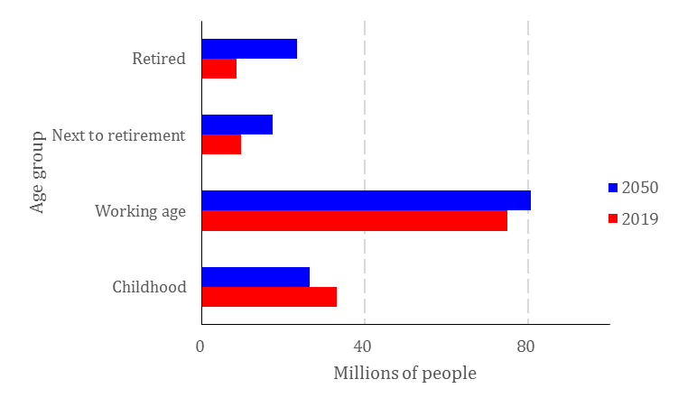

Fuente: CONAPO.

Figure 2. Mexican population structure by age and economic activity

September, 2019

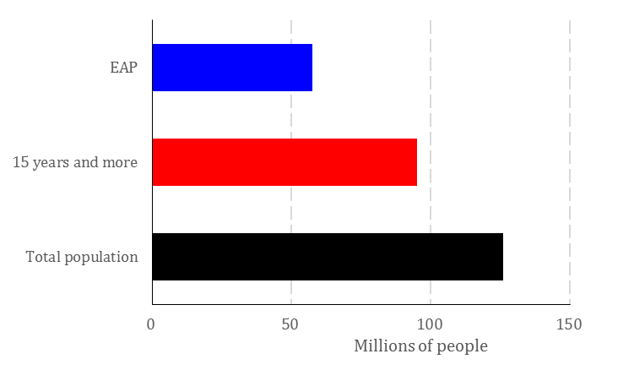

Source: Own elaboration with data from INEGI.

Figure 3. Mexican population structure with 15 years old and older by economic activity

Per cent

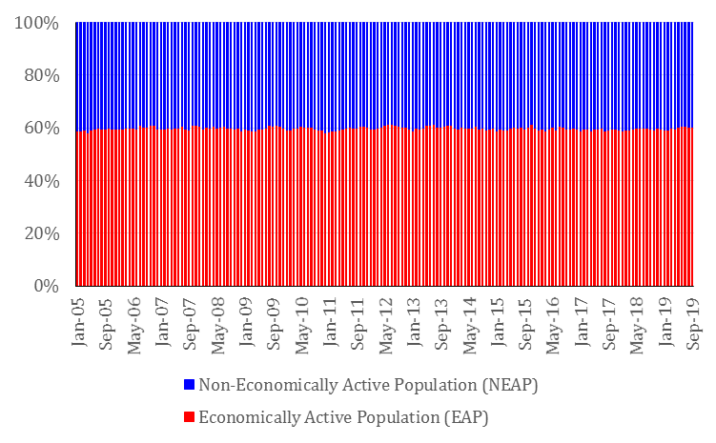

Source: INEGI

Figure 4. Economically Active Population by occupation

Per cent

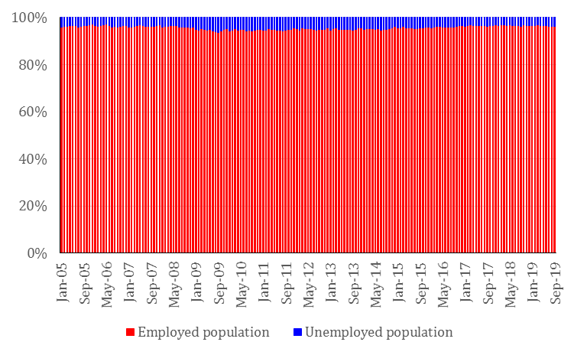

Source: INEGI.

Figure 5. Employed population by wage level

Per cent

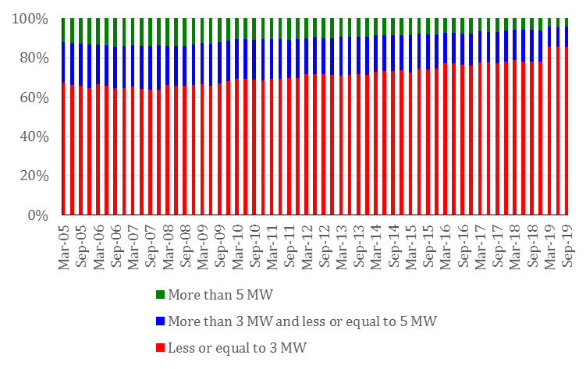

Source: INEGI

Figure 6. Daily salary associated with insured workers in IMSS

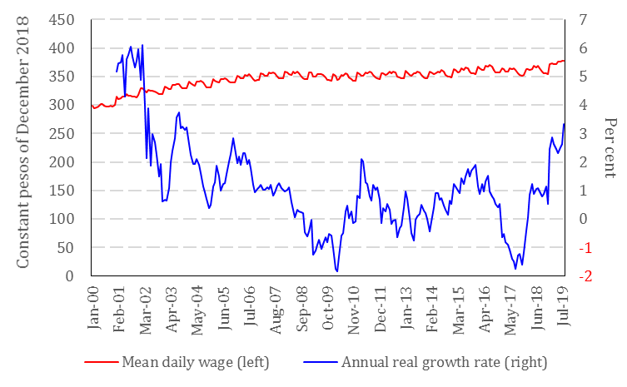

Fuente: Elaboración propia con datos de INEGI.

Figure 7. Labor Informality Rate

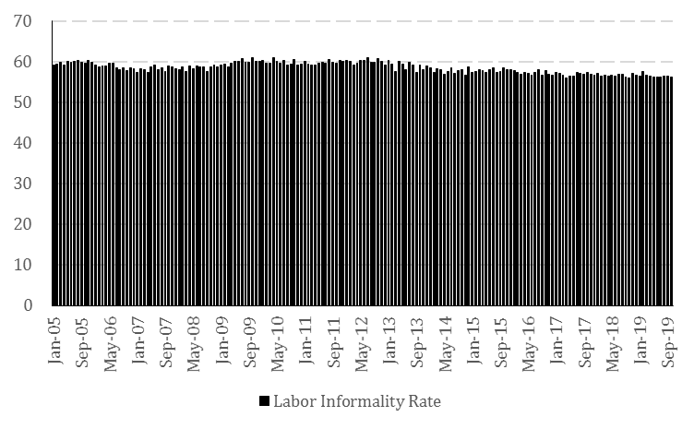

Source: INEGI

Figure 8. Evolution of managed accounts by SAR

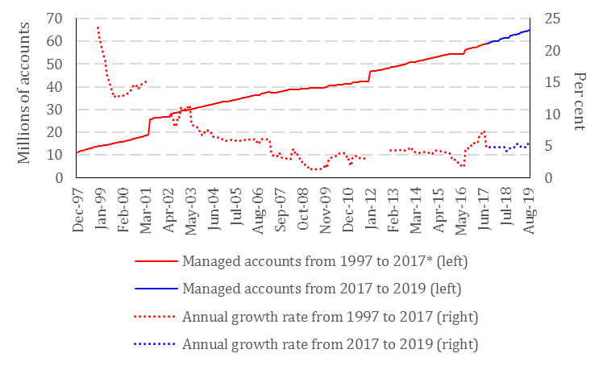

Source: CONSAR.

* The managed accounts series presents some inconsistencies on June 2001, January 2012 and August 2016. The three cases is because of the way in which is calculated the assigned accounts statistics.

Figure 9. Evolution of registered accounts in AFORES

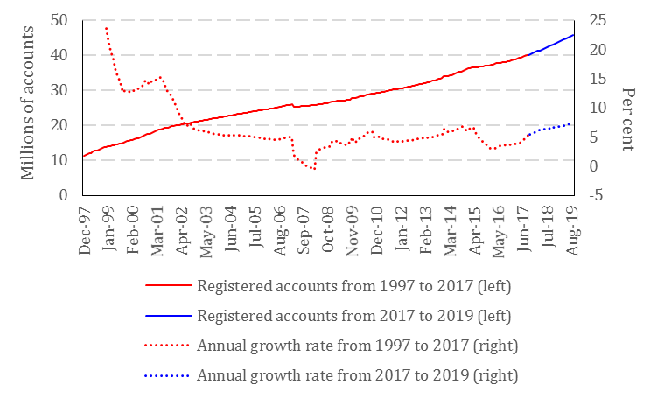

Source: CONSAR

Figure 10. Evolution of assigned accounts by SAR

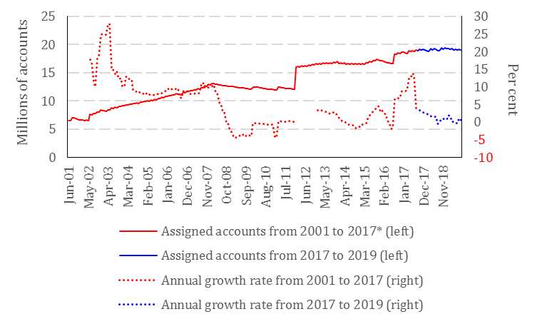

Source: CONSAR

* On January 2012 the accounts pending to be assigned are included to statistics; growth rates were excluded form analysis because they are not representative. On August 2016 a massive process of assignation of accounts is done by CONSAR.

Source: CONSAR

Figure 11. Evolution of registered accounts of independent workers

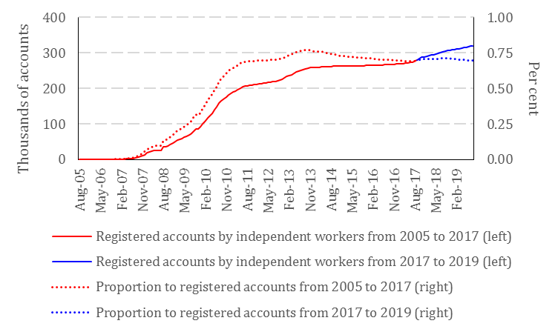

Source: Own elaboration with data from CONSAR.

Figure 12. Evolution of voluntary savings

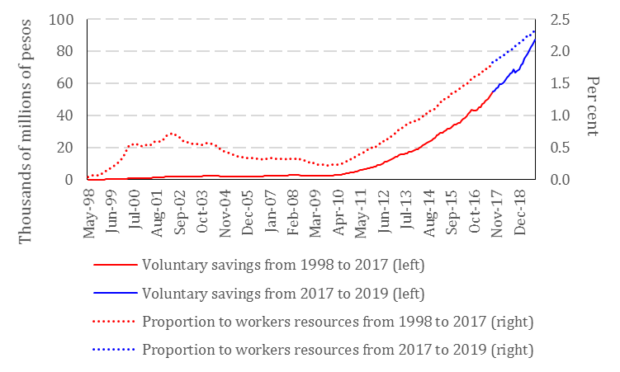

Source: CONSAR

1. See Table 1.
2. Comisión Nacional del Sistema de Ahorro para el Retiro. (2018). *Diagnóstico del Sistema de Ahorro para el Retiro en México: Funcionamiento, Beneficios y Retos*. p. 66.
3. Ramírez, C. (2017). *El Nuevo Ecosistema para Incrementar el Ahorro Voluntario en el Sistema de Pensiones de México*. p. 8.
4. OECD (2016). *Estudio de la OCDE Sobre los Sistemas de Pensiones: México*.
5. Grupo Interdisciplinario de Investigaciones Sistémico-Interpretativas, S.C.. (2017). *Pensiones y Jubilaciones en México: Situación Actual, Retos y Perspectivas*. p. 25.
6. Instituto Nacional de Estadística y Geografía. (2019). *Salario Diario Asociado a Asegurados Trabajadores en el Instituto Mexicano del Seguro Social*.
7. This data was obtained from multipying 30.4 for the daily sallary associated to private sector workers.
8. Equal to the mean of nominal growth rates of of sallary of private sector workers.
9. Instituto Nacional de Estadística y Geografía. (2019). *Salario Diario Asociado a Asegurados Trabajadores en el Instituto Mexicano del Seguro Social*.
10. Comisión Nacional del Sistema de Ahorro para el Retiro. (2019). *Indicador de Rendimiento Neto*.
11. Comisión Nacional del Sistema de Ahorro para el Retiro. (2016). *Encuesta de Trayectorias Laborales 2015*.
12. *Ley del Seguro Social*. (1995). Artículo 168.
13. OECD (2017). *Estadísticas de la OCDE sobre la salud*.
14. Comisión Nacional del Sistema de Ahorro para el Retiro (2019). *Indicador de Rendimiento Neto*.
15. Consejo Nacional de Población (2020). *Población a mitad de año.*
16. See Figure 1.
17. Instituto Nacional de Estadística y Geografía (2019). *Ocupación, empleo y remuneraciones.*
18. See Figure 2.
19. Instituto Nacional de Estadística y Geografía (2019). *Ocupación, Empleo y Remuneraciones.*
20. See Figure 3
21. Instituto Nacional de Estadística y Geografía (2019). *Ocupación, Empleo y Remuneraciones.*
22. See Figure 4.
23. Instituto Nacional de Estadística y Geografía (2019). *Ocupación, Empleo y Remuneraciones.*
24. See Figure 5.
25. Banco de México (2019). *Salarios Mínimos.*
26. Instituto Nacional de Estadística y Geografía (2019). *Ocupación, Empleo y Remuneraciones.*
27. See Figure 6.
28. Silva-Porto, M. *¿Cómo adaptar el estado del bienestar a la economía gig?* Inter American Development Bank.
29. OECD (2019). *Pensions at a Glance*.
30. Instituto Nacional de Estadística y Geografía (2019). *Encuesta Nacional de Ocupación y Empleo*
31. Instituto Nacional de Estadística y Geografía (2019). *Encuesta Nacional de Ocupación y Empleo.*
32. Gobierno de México (2019). *Plan Nacional de Desarrollo 2019-2024*. p. 60.
33. See Figure 7.
34. Comisión Nacional del Sistema de Ahorro para el Retiro (2019) *Información Estadística.*
35. Instituto Mexicano del Seguro Social (2019). *El IMSS en Números.*
36. OECD (2018) *Perspectivas Macroeconómicas de América Latina 2018*. p. 77.
37. OECD (2018) *Perspectivas Macroeconómicas de América Latina 2018*. p. 79.
38. Comisión Nacional del Sistema de Ahorro para el Retiro (2018). *Digitalización del SAR.* p.4.
39. Keller, L. & Tapia, W. (2019) *Tecnologías digitales para una mejor administración de pensiones*.
40. OECD (2018). *OECD Pensions Outlook 2018*. p. 141.
41. Inter American Development Bank (2019). *BID apoya programa de Paraguay para mejorar esquemas de pensiones.*
42. Silva-Porto, M. (2019). *¿Cómo adaptar el estado del bienestar a la economía gig?* 
43. Comisión Nacional del Sistema de Ahorro para el Retiro (2019). *Información Estadística.*
44. See Figure 8.
45. See Figure 9.
46. See Figure 10.
47. See Figure 11.
48. See Figure 12.
49. Instituto Nacional de Estadística y Geografía (2019). *Ocupación, Empleo y Remuneraciones.*